1.Write a program to store 15 integer values in an ArrayList and remove all duplicate elements without using another collection.
import java.util.ArrayList;
import java.util.Scanner;
public class RemoveDuplicates {
public static void main(String[] args) {
Scanner sc = new Scanner(System.in);
ArrayList<Integer> list = new ArrayList<>();
System.out.println("Enter 15 integer values:");
for (int i = 0; i < 15; i++) {
list.add(sc.nextInt());
}
// Remove duplicates without using another collection
for (int i = 0; i < list.size(); i++) {
for (int j = i + 1; j < list.size(); j++) {
if (list.get(i).equals(list.get(j))) {
list.remove(j);
j--;
}
}
}
System.out.println("ArrayList after removing duplicates:");
System.out.println(list);
sc.close();
}
}

OUTPUT:
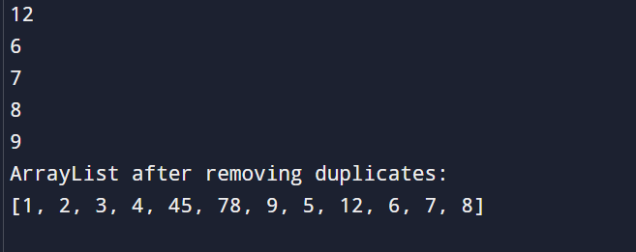
2. Store employee IDs in a LinkedList and display them in both forward and reverse order.
import java.util.LinkedList;
import java.util.Scanner;
public class EmployeeLinkedList {
public static void main(String[] args) {
Scanner sc = new Scanner(System.in);
LinkedList<Integer> empIds = new LinkedList<>();
System.out.print("Enter number of employees: ");
int n = sc.nextInt();
System.out.println("Enter Employee IDs:");
for (int i = 0; i < n; i++) {
empIds.add(sc.nextInt());
}
System.out.println("\nForward Order:");
for (Integer id : empIds) {
System.out.print(id + " ");
}
System.out.println("\n\nReverse Order:");
for (int i = empIds.size() - 1; i >= 0; i--) {
System.out.print(empIds.get(i) + " ");
}
sc.close();
}
}
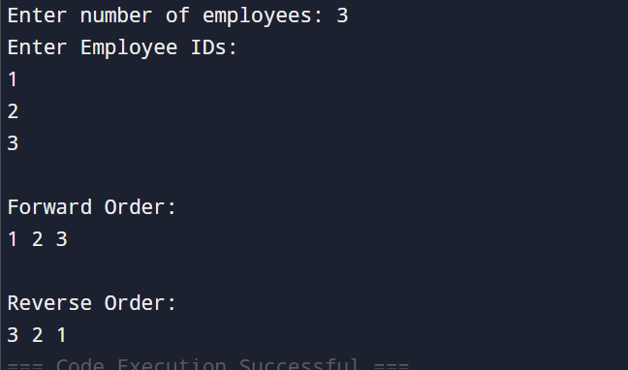
3. Store email IDs entered by the user in a HashSet. Display only unique email IDs and count the total unique entries.
import java.util.HashSet;
import java.util.Scanner;
public class UniqueEmails {
public static void main(String[] args) {
Scanner sc = new Scanner(System.in);
HashSet<String> emails = new HashSet<>();
System.out.print("Enter number of email IDs: ");
int n = sc.nextInt();
sc.nextLine();
System.out.println("Enter Email IDs:");
for (int i = 0; i < n; i++) {
emails.add(sc.nextLine());
}
System.out.println("\nUnique Email IDs:");
for (String email : emails) {
System.out.println(email);
}

System.out.println("\nTotal Unique Email IDs: " + emails.size());
sc.close();
}
}
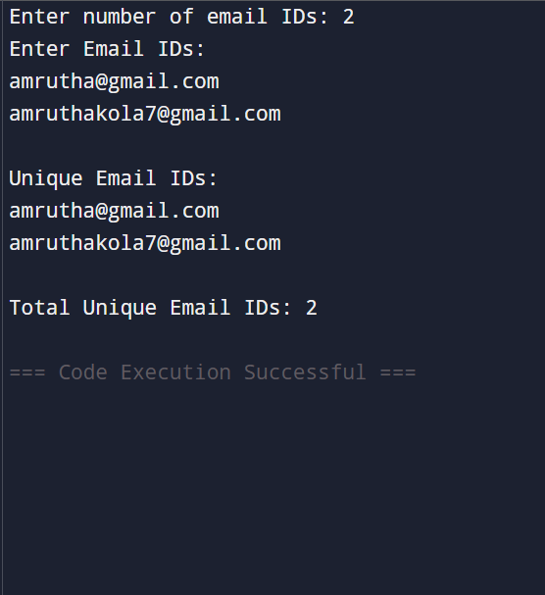
4. Write a Java program to count the frequency of each word in a paragraph using a HashMap.
import java.util.HashMap;
import java.util.Scanner;
public class WordFrequency {
public static void main(String[] args) {
Scanner sc = new Scanner(System.in);
System.out.println("Enter a paragraph:");
String paragraph = sc.nextLine();
paragraph = paragraph.toLowerCase().replaceAll("[^a-zA-Z ]", "");
String[] words = paragraph.split("\\s+");

HashMap<String, Integer> map = new HashMap<>();
for (String word : words) {
if (map.containsKey(word)) {
map.put(word, map.get(word) + 1);
} else {
map.put(word, 1);
}
}
System.out.println("\nWord Frequencies:");
for (String key : map.keySet()) {
System.out.println(key + " : " + map.get(key));
}
sc.close();
}
}
